**›Template Week 6 – Networking**

Student number: 588406

**Assignment 6.1: Working from home**

Screenshot installation openssh-server: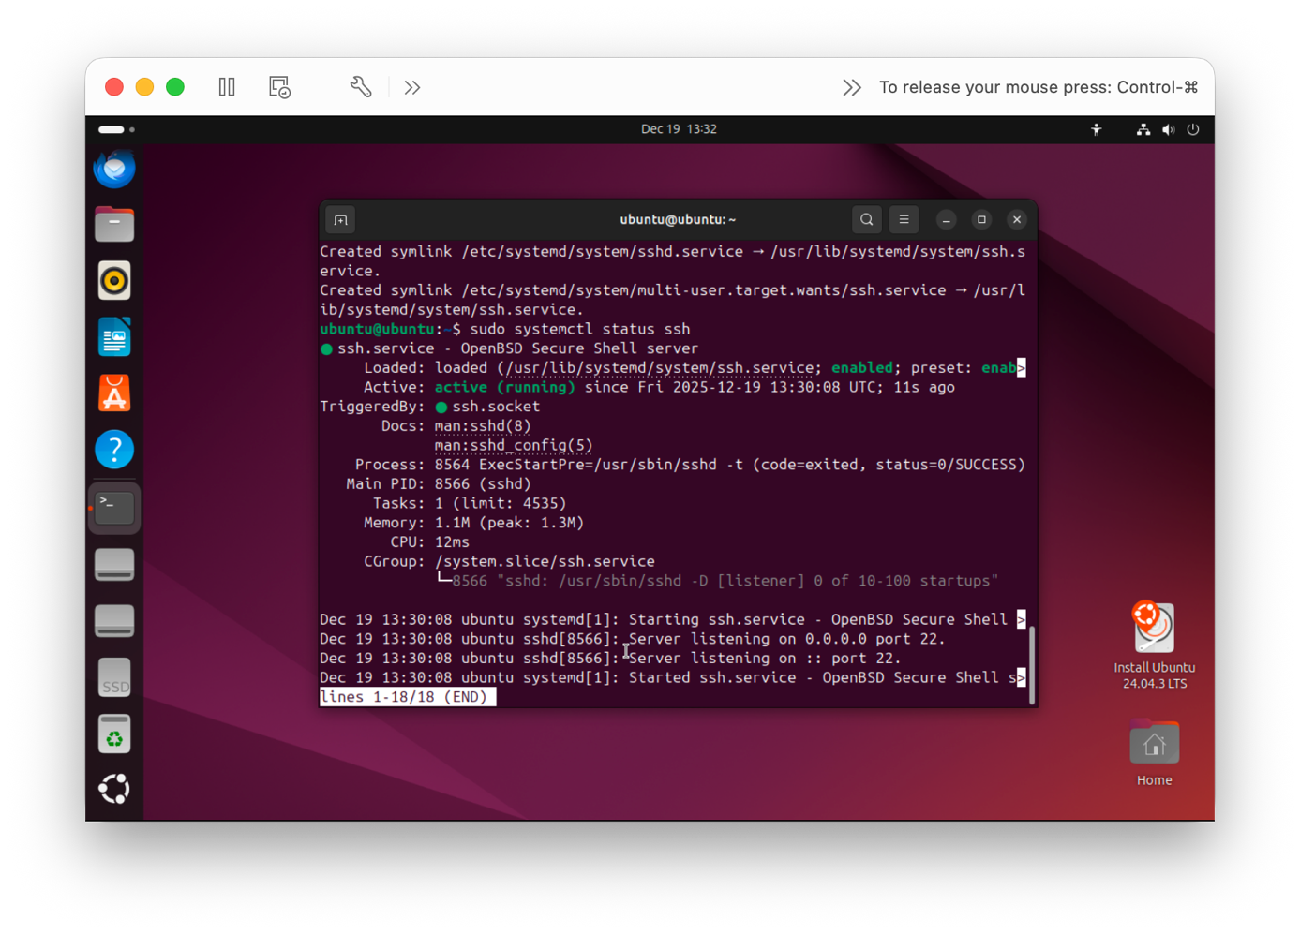

Screenshot successful SSH command execution:

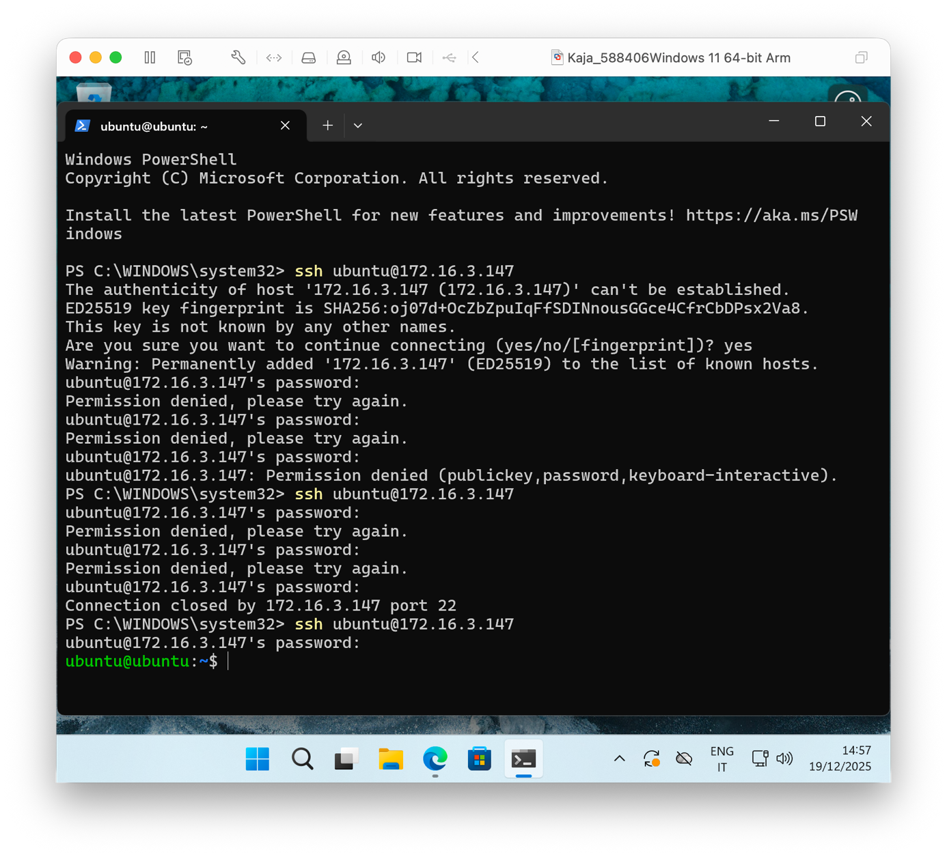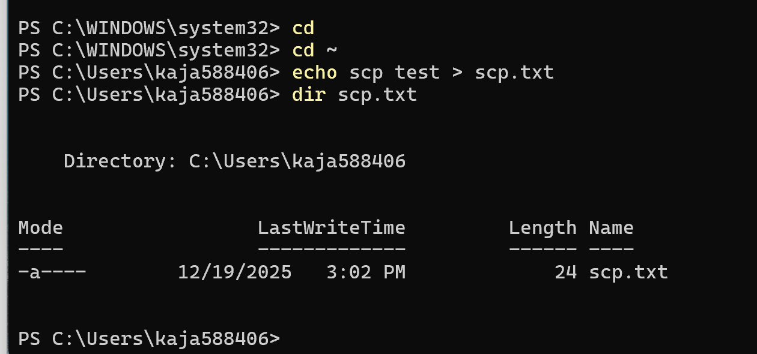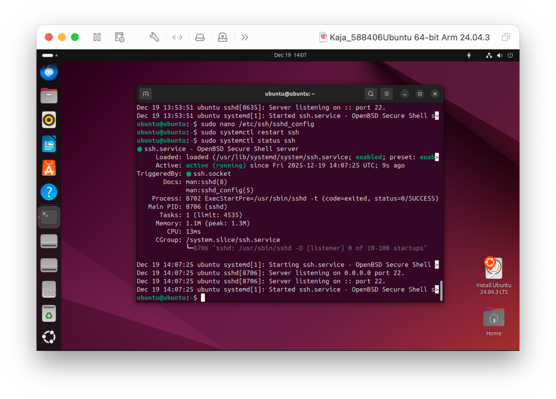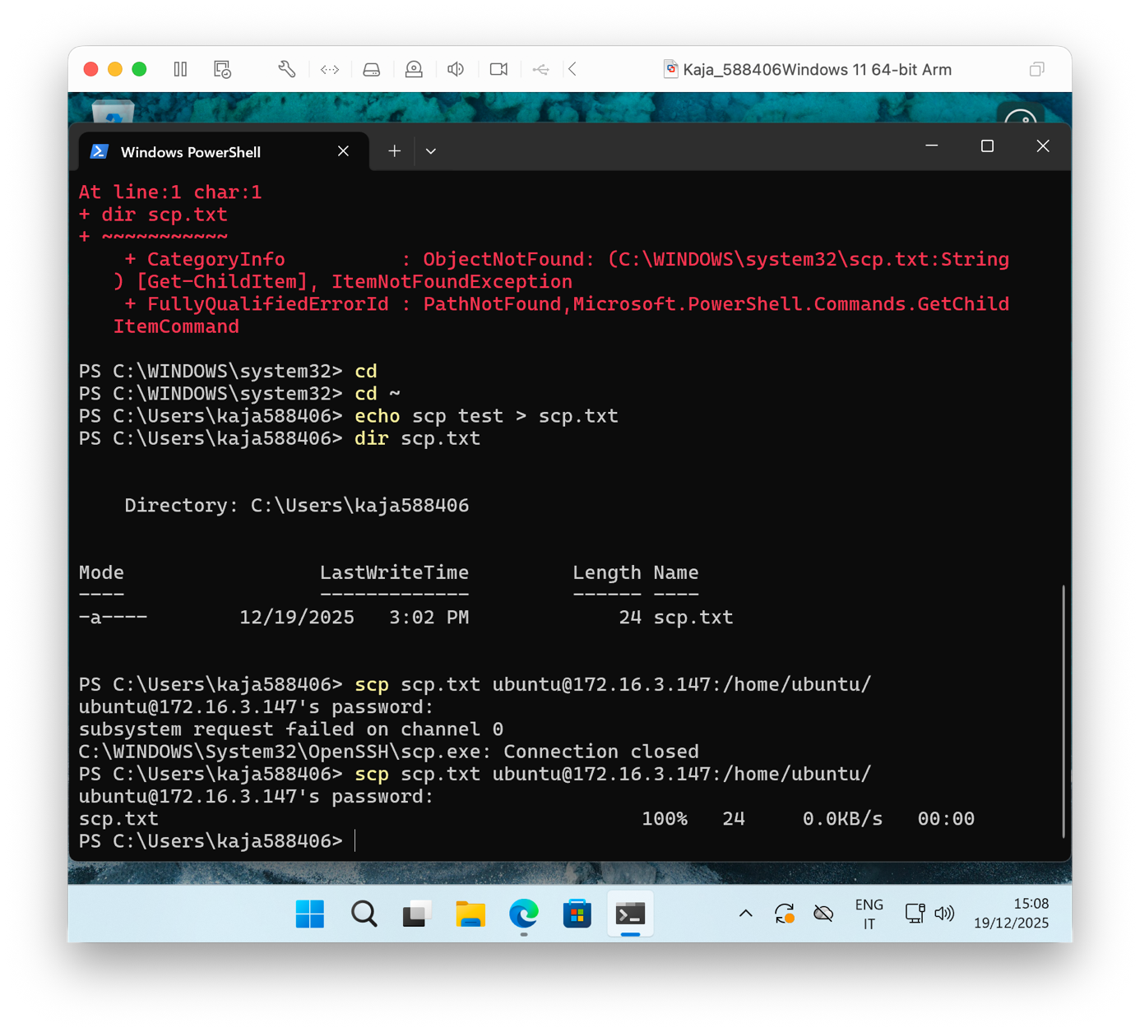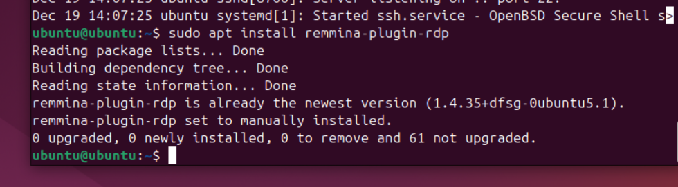

Screenshot successful execution SCP command:

Screenshot remmina:

**Assignment 6.2: IP addresses websites**

Relevant screenshots nslookup command:

Investigation IP addresses with nslookup command:

* amazon.com - 98.87.170.71, 98.87.170.74, 98.82.161.185
* google.com – 142.251.142.206, 2a00:1450:400e:806::200e
* one.one.one.one – 1.1.1.1, 1.0.0.1, 2606:4700:4700::1001, 2606:4700:4700::1111
* dns.google.com – 8.8.8.8, 8.8.4.4, 2001:4860:4860::8844, 2001:4860:4860:8888
* bol.com – 79.170.100.42
* w3schools.com – 76.223.115.82, 13.248.240.135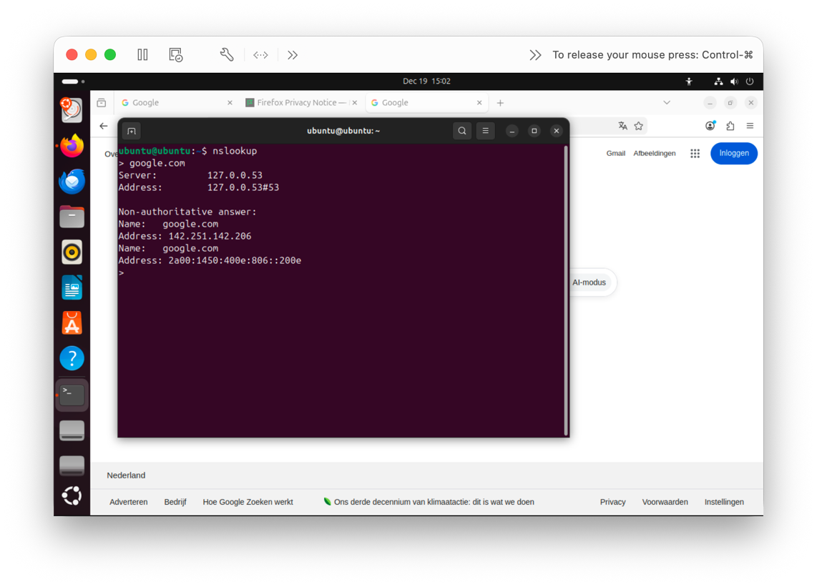

Screenshot website visit via IP address: 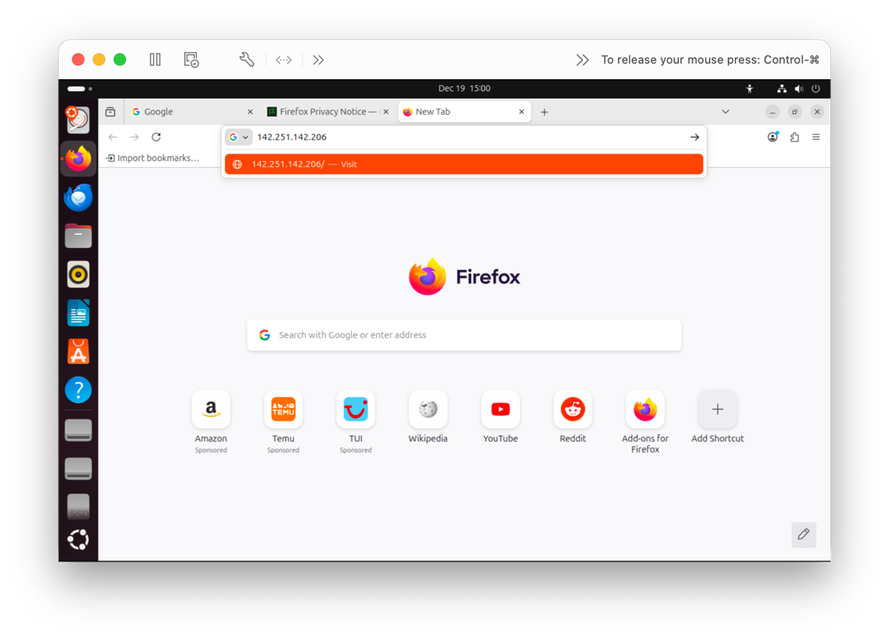

Assignment 6.3: subnetting

How many IP addresses are in this network configuration 192.168.110.128/25?

* The network 192.168.110.128/25 contains **128 IP addresses** in total.

What is the usable IP range to hand out to the connected computers?

* The usable IP range that can be connected to computers runs from 192.168.110.129 to 192.168.110.254.

Check your two previous answers with this Linux command: ipcalc 192.168.110.128/25

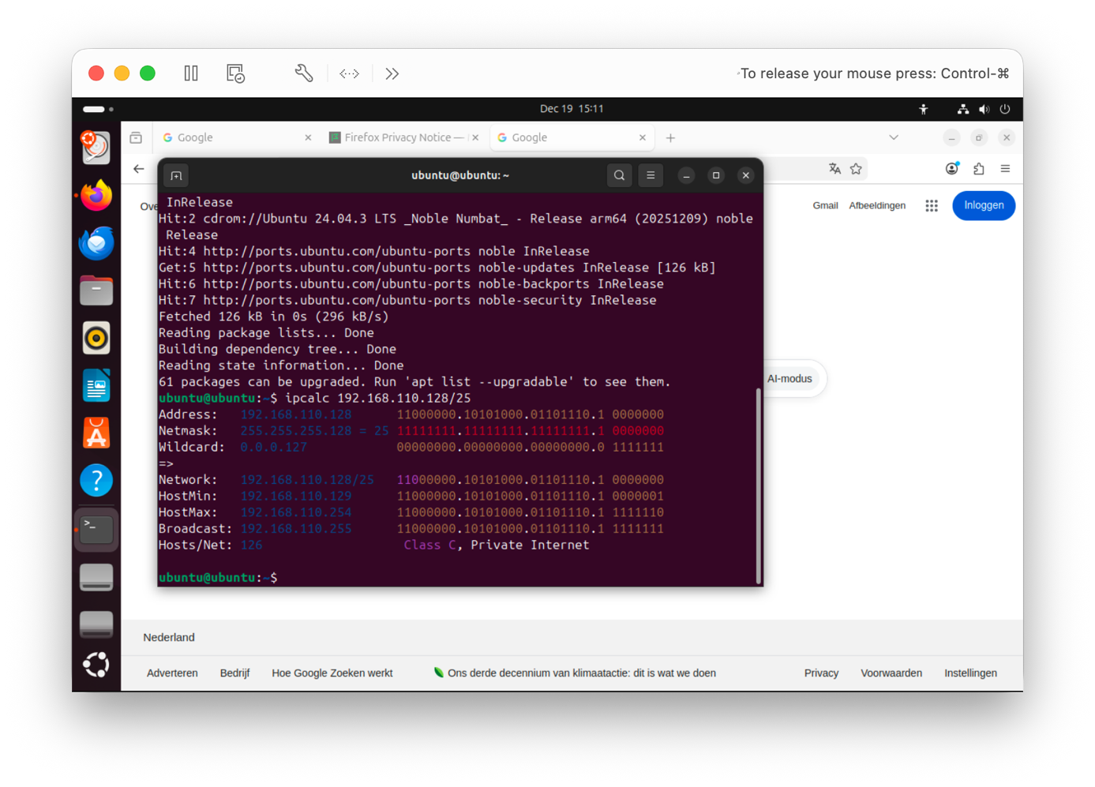

Explain the above calculation in your own words.

* This output confirms the calculation: with a **/25** subnet there are **128 total addresses**, where **192.168.110.128** is the network address and **192.168.110.255** is the broadcast address, leaving the usable host range **192.168.110.129 - 192.168.110.254** (126 usable IPs).

**Assignment 6.4: HTML**

Screenshot IP address Ubuntu VM:

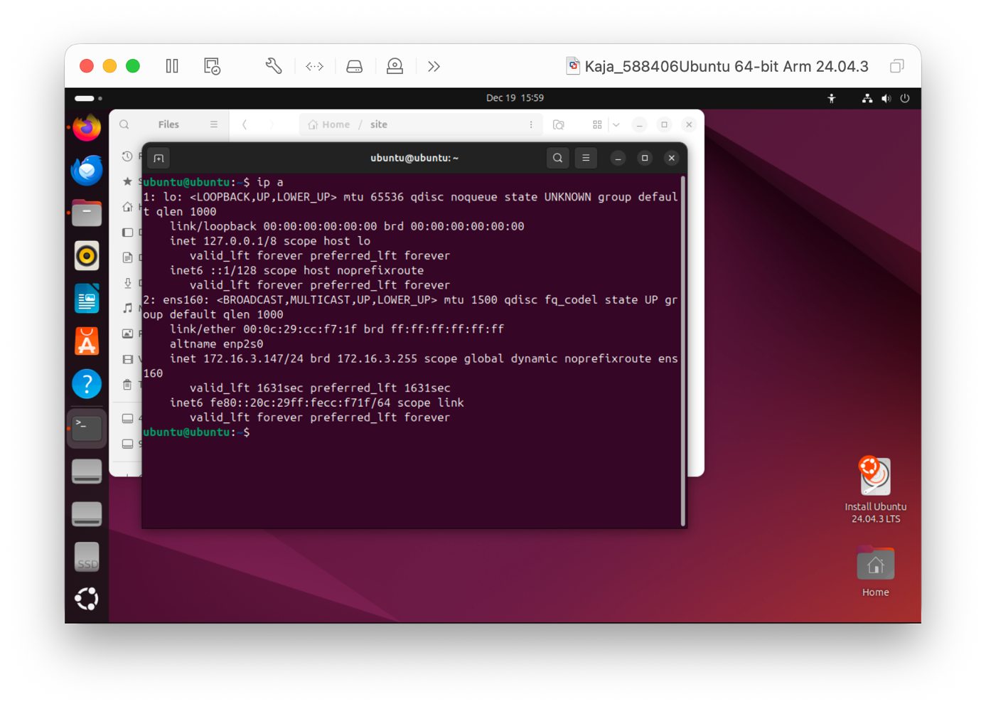

Screenshot of Site directory contents: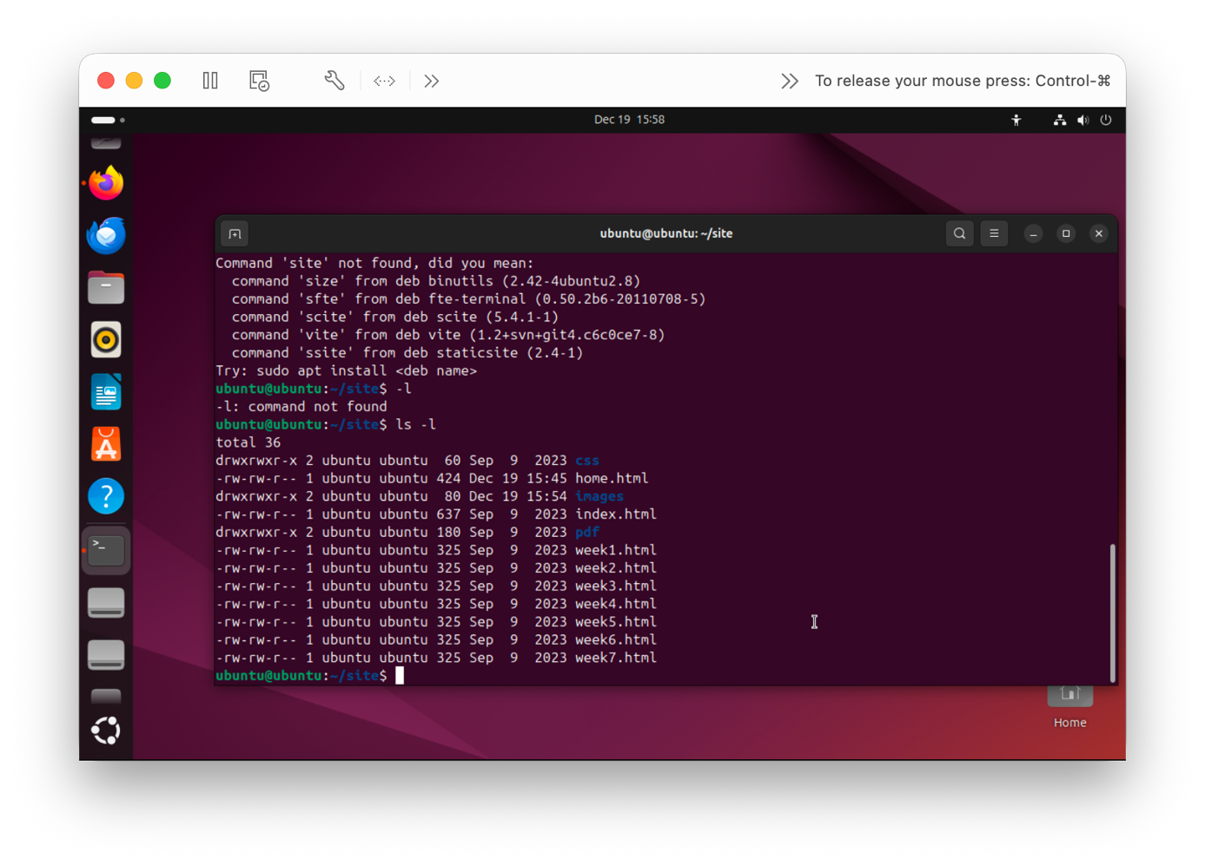

Screenshot python3 webserver command:

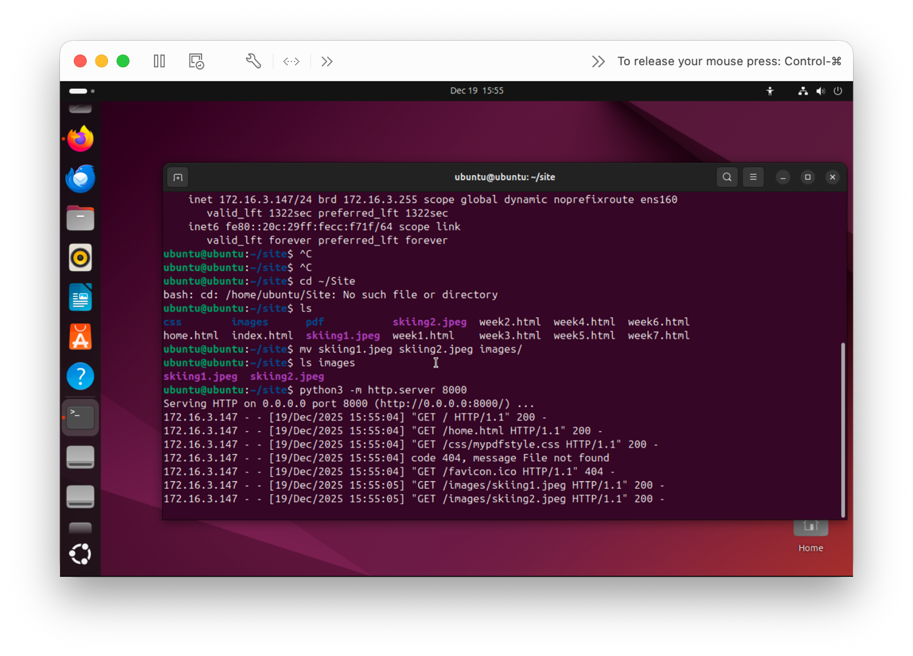

Screenshot web browser visits your site

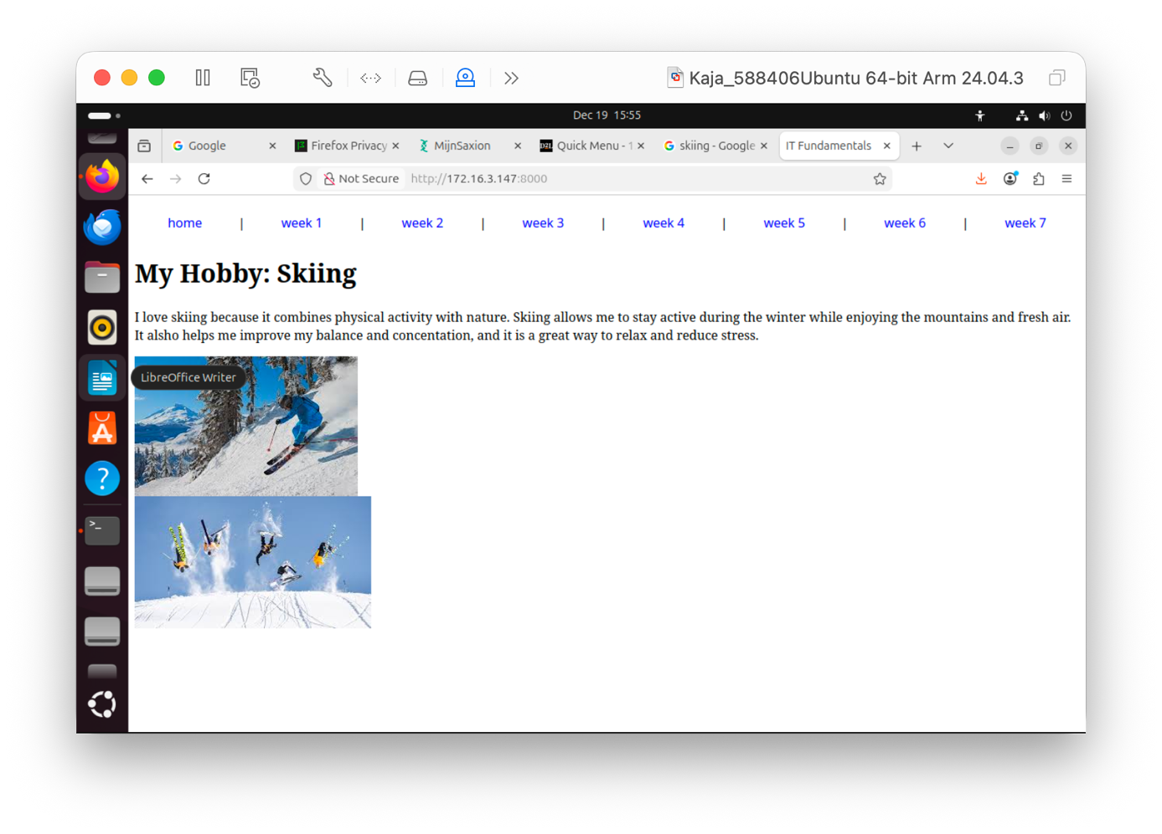

**Assignment 6.5: Network segment**

Remember that bitwise java application you’ve made in week 2? Expand that application so that you can also calculate a network segment as explained in the PowerPoint slides of week 6. Use the bitwise & AND operator. You need to be able to input two Strings. An IP address and a subnet.

IP: 192.168.1.100 and subnet: 255.255.255.224 for /27

Example: 192.168.1.100/27

Calculate the network segment

IP Address: 11000000.10101000.00000001.01100100

Subnet Mask: 11111111.11111111.11111111.11100000

-------------------------------------------------

Network Addr: 11000000.10101000.00000001.01100000

This gives 192.168.1.96 in decimal as the network address.

For a /27 subnet, each segment (or subnet) has 32 IP addresses (25). The range of this network segment is from 192.168.1.96 to 192.168.1.127.

Paste source code here, with a screenshot of a working application.

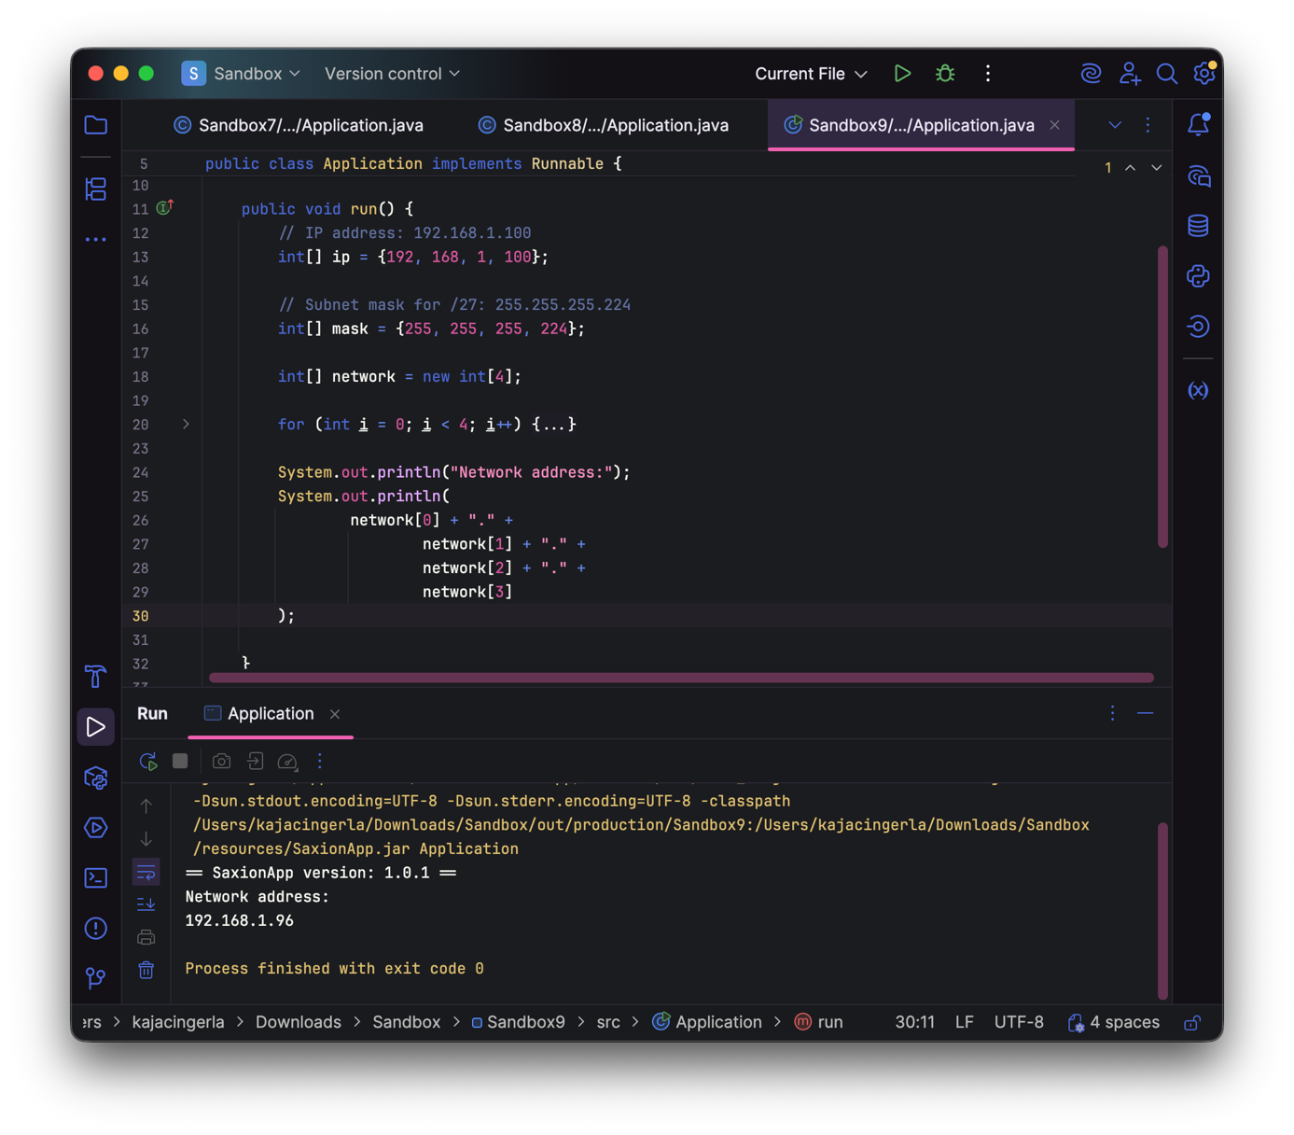

Ready? Save this file and export it as a pdf file with the name: **week6.pdf**